Coil Assembly

Prep:
- Connect Heads-Up Display to a 24V, 5W Power supply, and a 5V Micro USB

Procedure:
- Install Magnet Wire spool, insert through the Wire guide and through the optional tensioner assembly
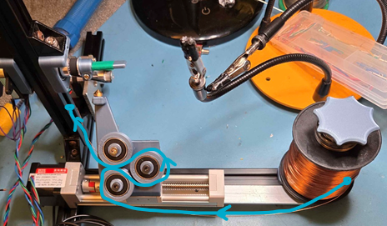
- Setup Bobbin onto the spinning pin as shown. Kapton or Electrical tape may be used for improved surface adhesion if necessary.
- Rotate the bobbin 45degrees, wide face up and pass the magnet wire through the nozzle tip. Be careful as to not reel the magnet wire back after insertion, the nozzle tip can strip away the wire’s coating.
- Pass the wire around the top facing notch of the bobbin and loop the end of the wire around the bottom of the screw, or around the left of the assembly.
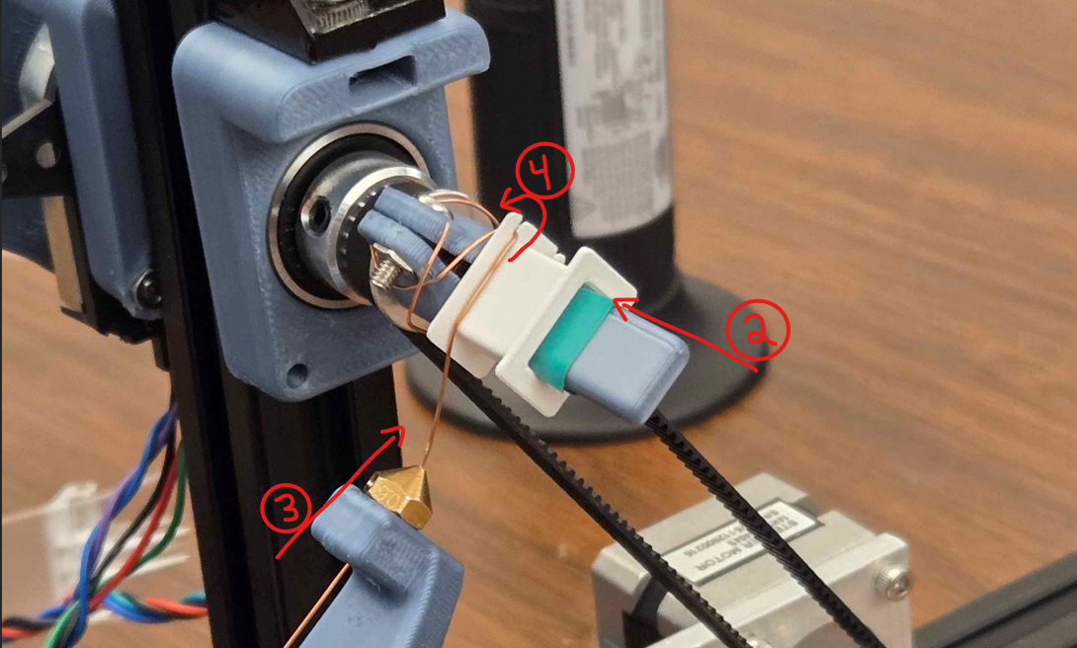

- Wind the bobbin further than the initial 45 degrees to create an initial tension on the spool.

Automated Winding Process
- On the Heads-Up display, first select the “HOME” button to allow the motors to all be defined at their “zero” points.
- Once ready, start the coil winding process by selecting “START” on the Heads-Up display
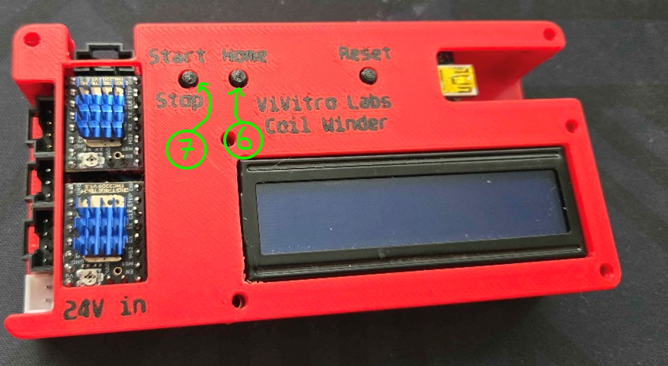
- After the bobbin has been complete, cut magnet wire about an inch from the wound base, and fold onto the other notch in the bobbin.
- Disconnect bobbin from the work pin and repeat steps until desired count of bobbins is reached
